Connect to one of the EC2 instances and remove the health.html file. Remember this is the file used for health check in the load balancer target group.

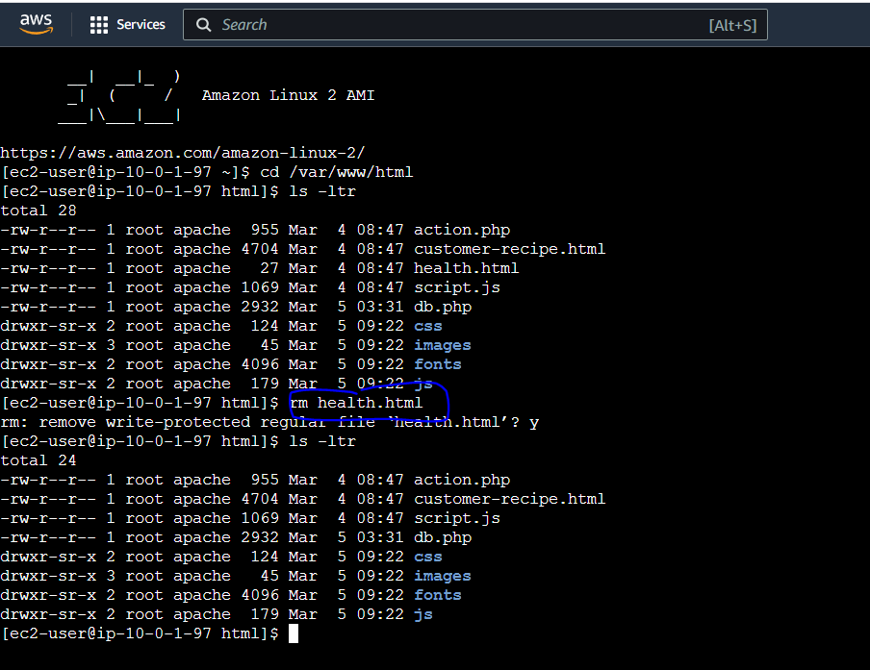

The Auto Scaling Group that uses the load balancer detects this, terminates the instance and launches a replacement instance. You should see the below 2 activities in the ‘Activity’ tab of the Auto Scaling Group.

